Elder Care Medicine Network | 
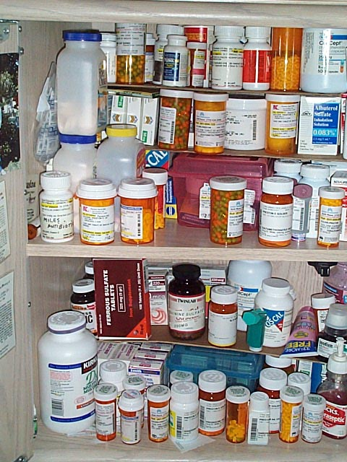 | - Do you want to be part of a team with older adults, caregivers, pharmacists, and researchers focusing on the best use of medicines?  This is your chance to help!

Medicines can be lifesaving but can also cause harm and are often studied in people younger than 65. One thing we can do is figure out which medicines and doses are the most helpful for older adults. This includes prescription, over the counter medicine and supplements.
If you are at least 65 years old and take medications, or you are a family member caring for someone in this age group, your experiences may help us to learn how to make medications and taking medications better for older people.

Elder Care Medicine Network

We are building a network that trains you in “Patient Centered Outcomes Research” (PCOR) on the topic of best use of medicines for older adults.

Our network is a group of people working on how best to use medicines.

We offer many ways to work with us, like surveys, focus groups, trainings, and the chance to participate in conversations about health.

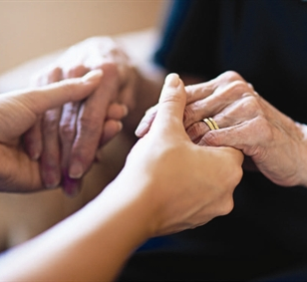
Whether you are an older patient, caregiver, a researcher, or a pharmacist – our project will engage you where you can be an equal partner in improving the use of medicines as we age.

How we plan to develop this network

We have chosen three regions for this project, but even if you are located elsewhere, you can still engage in this network

We want to make sure older adults are at the heart of the research questions that this network promises to address.

How your information will be used

- We will only use your information for network related activities
- We will work with you to ensure your engagement is possible on the format, time and language that is accessible to you

